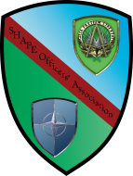

**SHAPE Officers’ Association Newsletter, December 2018**

**Summary report of the 58th SOA Symposium**

The SHAPE Officers’ Association (SOA) held its 58th annual Symposium on 11-13 October at SHAPE. Once again, this major SOA event brought back to Casteau members from across the Alliance for academic and social activities. General (Ret.) John A. Shaud, SOA President, chaired this year’s symposium that like all other SOA activities is designed to preserve and foster the spirit of fellowship among its members and to provide a forum that brings current and former SHAPE personnel together to exchange views and experiences.

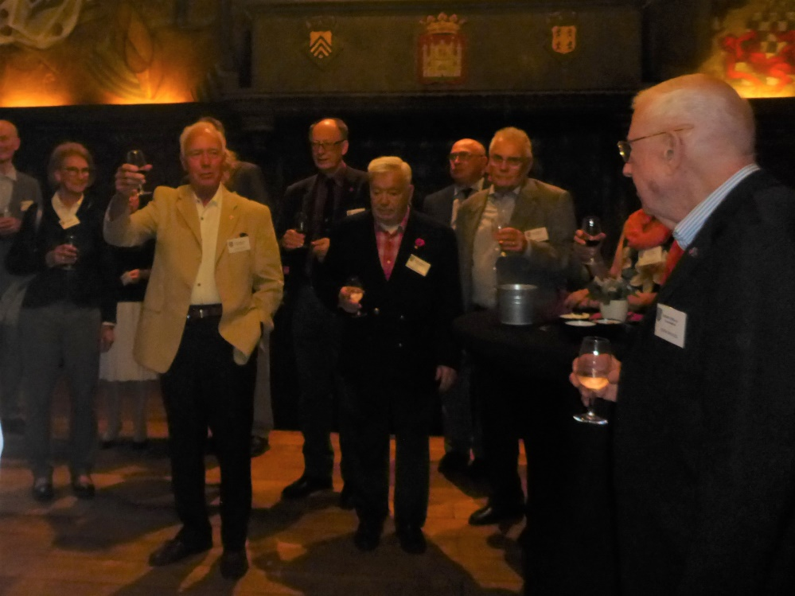

Following tradition, the Symposium began with a Happy Hour on Thursday 11 October. This year’s reception was hosted in the beautiful “Salle des Mariages” of the Town Hall of Mons.

The reception was the beginning of the renewal of friendships and SHAPE memories. Attendees followed the reception with dinner at local restaurants.

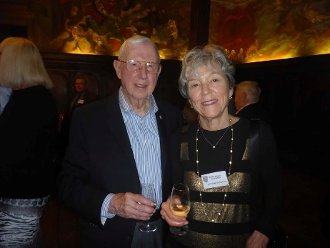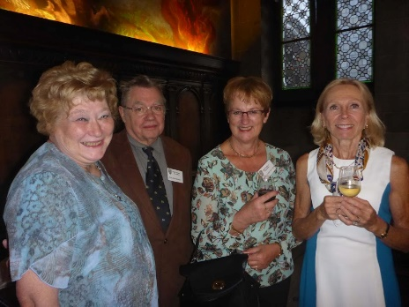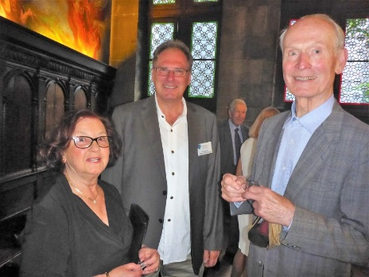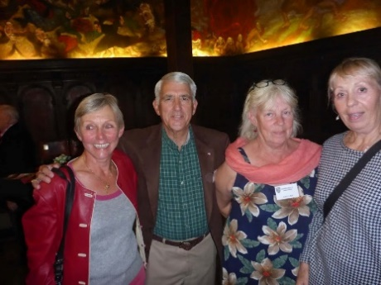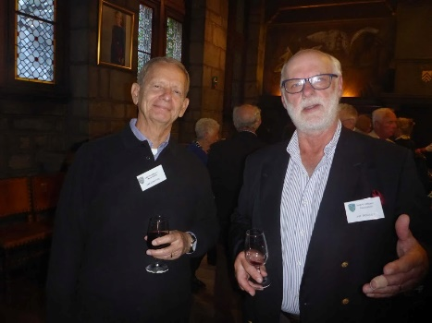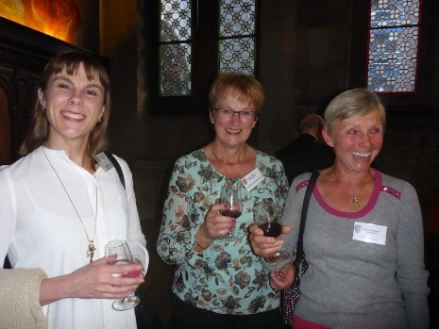

The next day, 12 October, the Symposium began with the General Assembly in the SHAPE Club, a very important part of the SOA calendar as all the major decisions pertaining to the life of the SOA are taken. The record of decisions of the 58th SOA Symposium is provided in a separate section below.

A highlight of the General Assembly was the awarding of an SOA Scholarship to distinguished high school graduates either sponsored by an SOA member or nominated by the Director General, SHAPE International School (SIS). This year’s recipients were Elizabeth Morrow (SOA Dependent) and currently at Pennsylvania State University and Maria-Lucia Rebrean (SIS Student) currently enrolled at Vrije Universiteit Brussel.

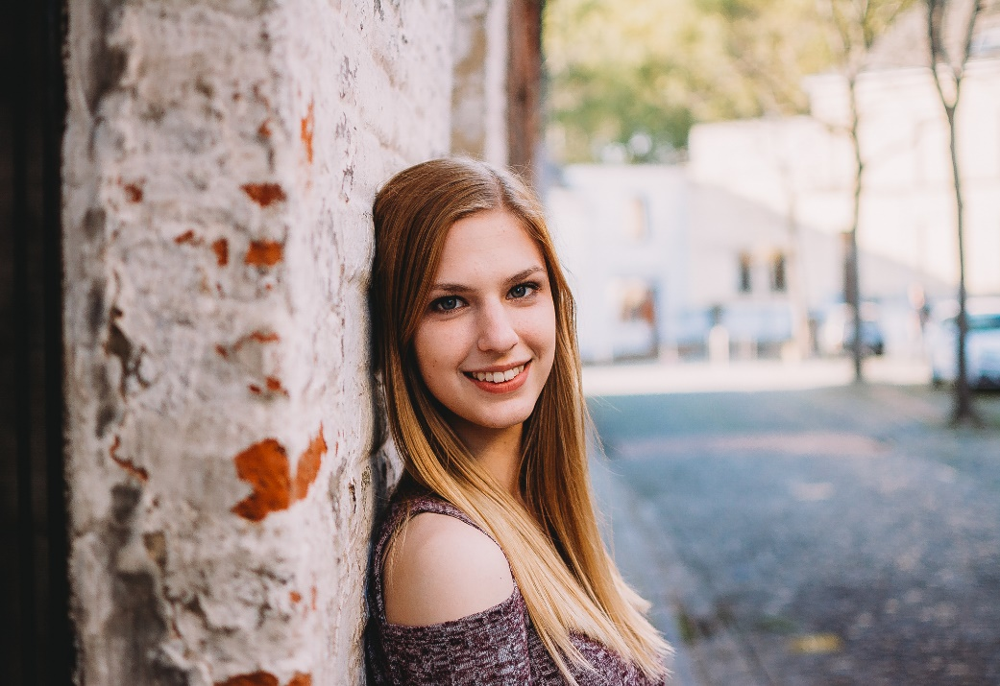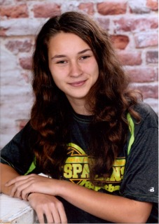

Elizabeth Morrow Maria-Lucia

Each of them will receive a certificate that comes along with a scholarship award of 1,000 EUR. Unfortunately, neither of the awardees was available to receive their award as they are currently enrolled in universities. However, Gen. Shaud was able to present the SOA Scholarship Certificate to Maria-Lucia’s father. Elizabeth’s Certificate was presented to her at the US Chapter Holiday Dinner.

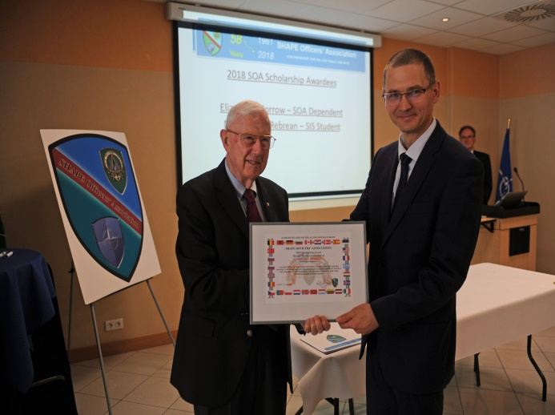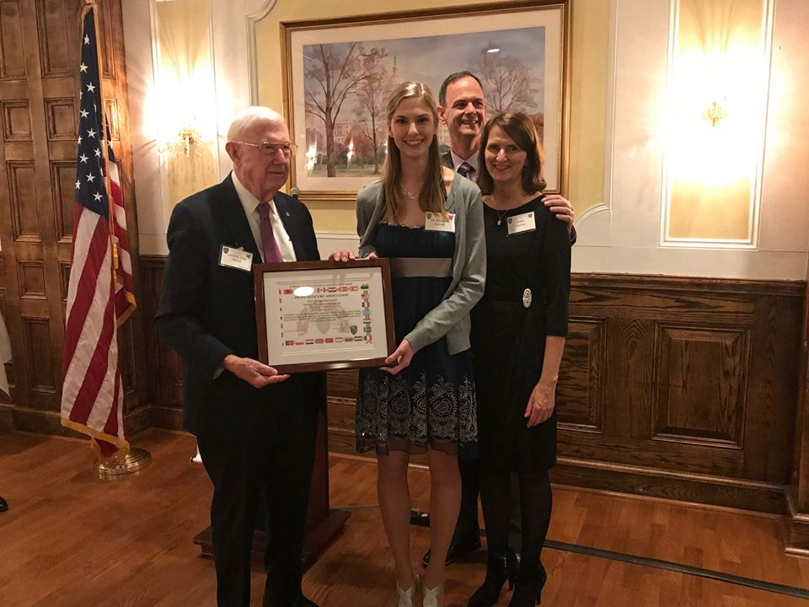

Following lunch at the SHAPE Club, the Symposium continued with a series of excellent briefings on NATO and SHAPE related topics. This informative afternoon session was designed to keep members informed about SHAPE and the military situation in NATO and to enable them to support and propagate the mission and the objectives of SHAPE and, more generally, to help sustain the Alliance.

These included an ACO Update Briefing by MGen. Scott Kindsvater, DCOS Operations and Intelligence.

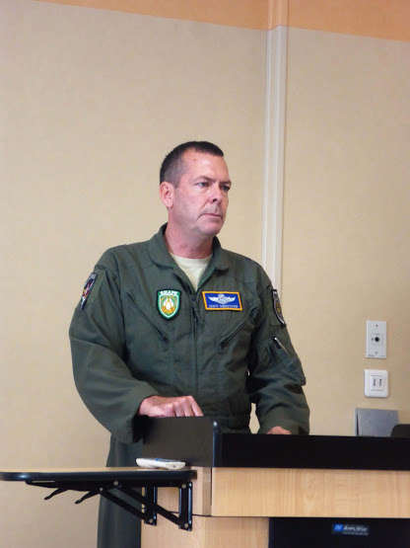

He discussed on-going NATO operations and exercises which clearly exceeded the activities that many SOA members recall from their time at SHAPE. There are NATO forces on the Resolute Support Mission in Afghanistan and the recently completed Trident Juncture Exercise in Norway.

There was also a presentation of NATO Communications and Information Agency (NCIA) by Mr. Greg Edwards, Director Service Operations.

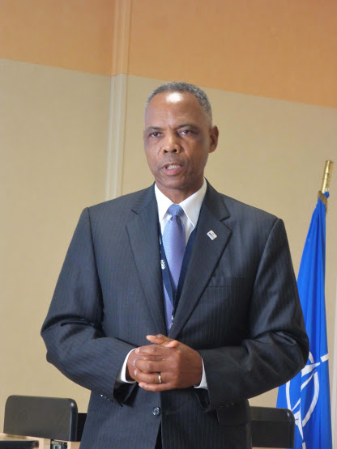

**NCIA is NATO's technology and cyber leaders. NCIA helps NATO Nations communicate and work together in smarter ways. NCIA solutions underpin NATO's ability to perform Article IV (consultation) and Article V (command and control).** NCIA cooperates with industry and academia to provide resilient C4ISR* technology that saves lives and safeguards peace for nearly 1 billion citizens.

Importantly, the briefings and dialogue with the presenters enabled the attendees to appreciate how SHAPE has changed since their time in Belgium.

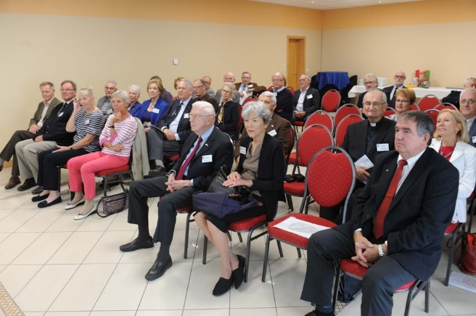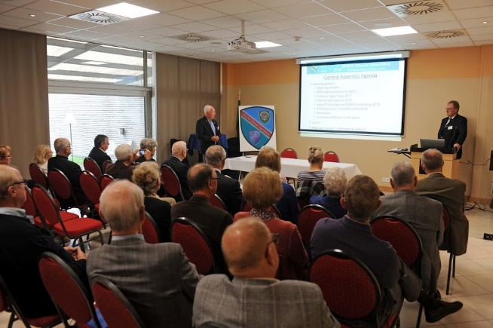

Saturday, 13 October, began with a cultural trip that included a visit to the Atomium in Brussels in celebration of its 60th anniversary. It was a real adventure reaching the top and enjoying the spectacular view of Brussels.

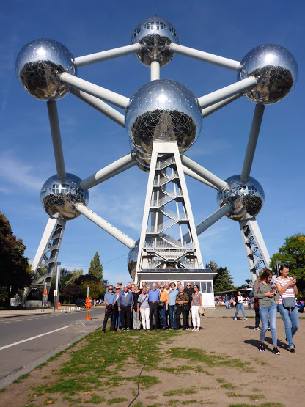

The SOA Symposium concluded with the traditional annual dinner, this year at Bouton d’Or in Casteau. We were privileged to have SACEUR, Gen. Scaparrotti join us for the dinner. He visited every table for discussions with SOA members.

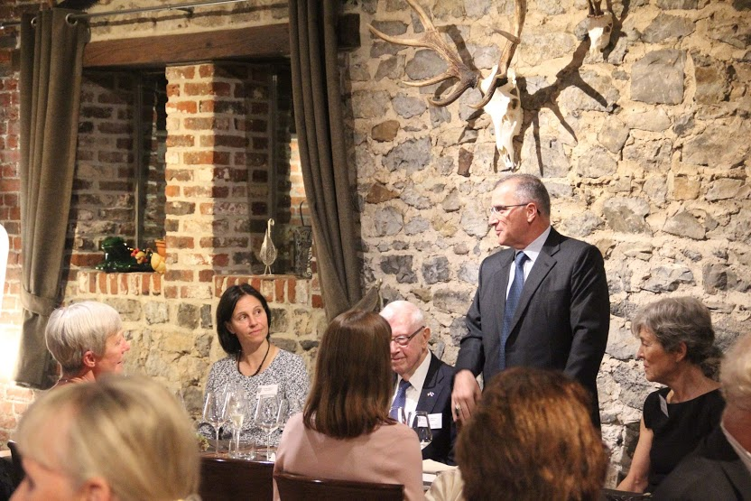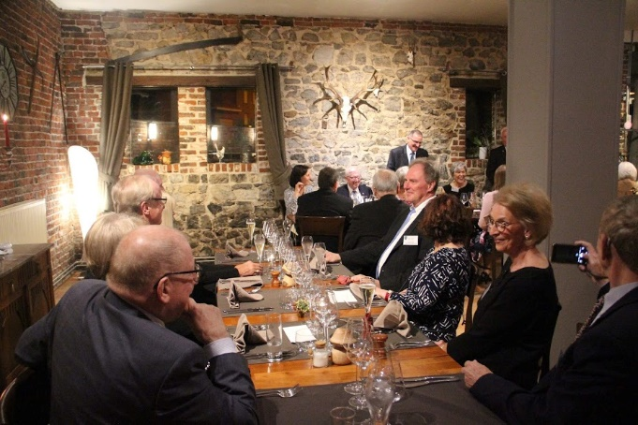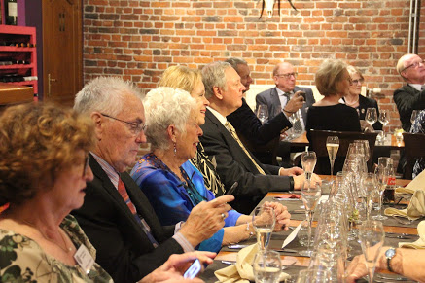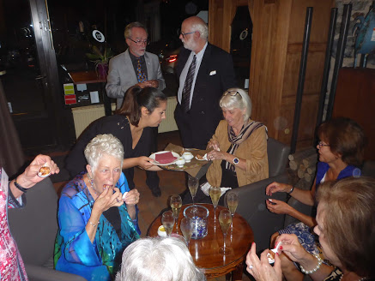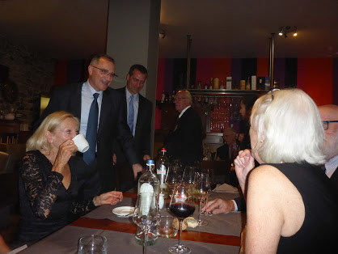

Sadly, this also brought this successful symposium to an end. But participants left very satisfied and with a lot of good memories of this great series of events, and hopeful that they will meet one another again at the 59th SOA Symposium to be held at SHAPE in October 2019.

|  |
| --- |
| **More photos about the 58th SOA Symposium can be found at**  Townhall reception :  <https://photos.app.goo.gl/Gaio7gg9GZGN8XDWA>  Symposium :  <https://photos.app.goo.gl/16SRHzLZEjiGkvbR8>  Cultural trip :  <https://photos.app.goo.gl/yZBDXJPzJoNz6LH48>  Dinner :  <https://photos.app.goo.gl/HEuN5R4tCBc4Czk2A> |

In conclusion, we have learned this year of the passing of several of our SOA members. They were:

**Ray Miller, COL US Army**

**Randy Peat, LtGen US Air Force**

**John Purdy, LTC US Army**

**George Seamonds, COL US Army**

**Sonny Simerly, COL US Army**

**Galen Stone, US Ambassador**

Their friendship, participation and support of SOA will be missed.

***Other Planned SOA Activities for 2019***

**January**: New Year Happy Hour at **SHAPE**

**February**: Candlemas celebration at **SHAPE**

**15-17 March**: **US Chapter** Florida Fun Weekend

Quarterly **US Chapter** luncheons

**US Chapter** visits to local military historical locations

Envisaged/possible activities in **Belgium**:

* Wine and cheese party
* Visit of the new NATO Headquarters
* Visit of the Hôpital Notre-Dame à la Rose at Lessines

**October**: 59th SOA Symposium **(SHAPE)**

**December**: **US Chapter** Annual Dinner

**Record of decisions of the 58th SOA Symposium**

At its 12 October 2018 gathering, the SOA General Assembly:

* Noted the SOA activity reports for 2018 and the outlook for 2019 provided respectively by the Co-Chairman, Executive Committee and the Chairman, US Chapter
* Noted the Treasurer‘s Financial Report for 2017
* Endorsed the awarding of the SOA Scholarships 2018 iaw the Expanded Programme to:

Elizabeth Morrow – SOA Dependent – Pennsylvania State University

Maria-Lucia Rebrean – SIS Student – Vrije Universiteit Brussel

* Endorsed the carrying funds forward to the 2019 SOA Scholarships
* Encouraged more SOA membership participation in the SOA Scholarship Program, both financially and in providing applicants
* Agreed to continue to use the SOA General Fund to supplement the SOA Scholarship Fund to:
* Match all voluntary contributions by SOA members to the SOA Scholarship Fund
* Allow the awarding of at least two scholarships per year (subject to reassessment in 2019) iaw the Expanded SOA Scholarship Program
* Expressed its appreciation to the Executive Committee for the practical organization of the 58th SOA Symposium
* Requested the Executive Committee to include a summary of the proceedings of this year‘s Symposium and the detailed Record of Decisions in the next SOA Newsletter for the benefit of the entire SOA membership
* Noted the suggestions made during the General Assembly, to be further considered by the Executive Committee:
* Publication of the scholarship applicants/nominees “statement of goals” to be shared among the SOA membership
* Interact with the COM DIV on how the SOA and its members could better serve as “engagers“.

**SOA Executive Committee 2018-2019**

|  |  |
| --- | --- |
| MajGen Marin Natchev, BGR F (Ret.) | Chairman |
| Col John Haas, USA F (Ret.) | Co-Chairman |
| Mr. Günter Bretschneider, NATO CIV (Ret.), DEU | Secretary |
| LtCol Krzysztof Plazuk, POL A | SHAPE COM DIV Liaison |
| Mrs. Véronique Leroy, NATO CIV (Ret.), BEL | Treasurer |
| Mr. Jean Vanderwal, NATO CIV (Ret.), BEL | Web Content Manager and  Assistant Treasurer |
| Cdt Jean-Marie Boulet, BEL A (Ret.) | Administrator and Data Base (DB) Manager |
| Mr. Jack Smits, NATO CIV (Ret.), NLD | Publications Manager and  Assistant DB Manager |
| Col Benoît Davin, BEL F (Ret.) | Scholarships coordinator |
| Col Raymond Healy, USA F (Ret.) | Volunteer |

**SOA Scholarship Fund**

Thanks to the generosity of SOA members and in keeping with the funding principles of SOA Scholarships we were in a position this year to award two scholarships to most deserving high school graduates (see summary of the General Assembly above).

The success of the SOA Scholarships program depends however heavily on continued voluntary donations from SOA members. You are therefore encouraged to support it by making a donation.

In Europe, the account number is: Fortis Bank, SOA Scholarships Account. IBAN: BE09 0357 9189 9957 (BIC: GEBABEBB).

For American SOA Members desiring to make a donation:  please contact your local Chapter.